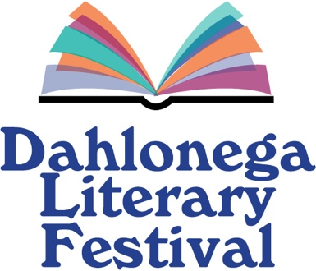

2025 Sponsorship for the Dahlonega Literary Festival
We are proud to sponsor the 2025 Dahlonega Literary Festival with a tax-deductible contribution.
_____ Platinum ($1000 and above) Four tickets to a ticketed event; Sponsorship of a
Festival special event with signage at the event and inclusion in DLF promotional
materials.
_____ Gold ($750 to $999) Two tickets to a ticketed event; Sponsorship of a room at DLF with
signage and inclusion in DLF materials.
_____ Silver ($500 t0 $749) Sponsorship of a panel, with signage at the event and inclusion in
DLF promotional materials.
_____ Bronze ($250 to $499) Name included in DLF materials.
_____ Friend ($100 to $249) Name included in printed program.
Please write your name EXACTLY as you would like it to appear on printed material. If you wish your name not to appear, please write “Anonymous.”
Name _______________________________________________
Address: _______________________________________________
City/State/Zip ______________________________________________
Telephone: ______________________________________________
Email address: _____________________________________________
PAYMENT INFORMATION
____ Enclosed is a check/money order $______ (made payable to the Dahlonega Literary Festival and sent to P.O. Box 1401, Dahlonega GA 30533)
____ Paypal.com: www.literaryfestival.org
THANK YOU for your support of the Dahlonega Literary Festival.

